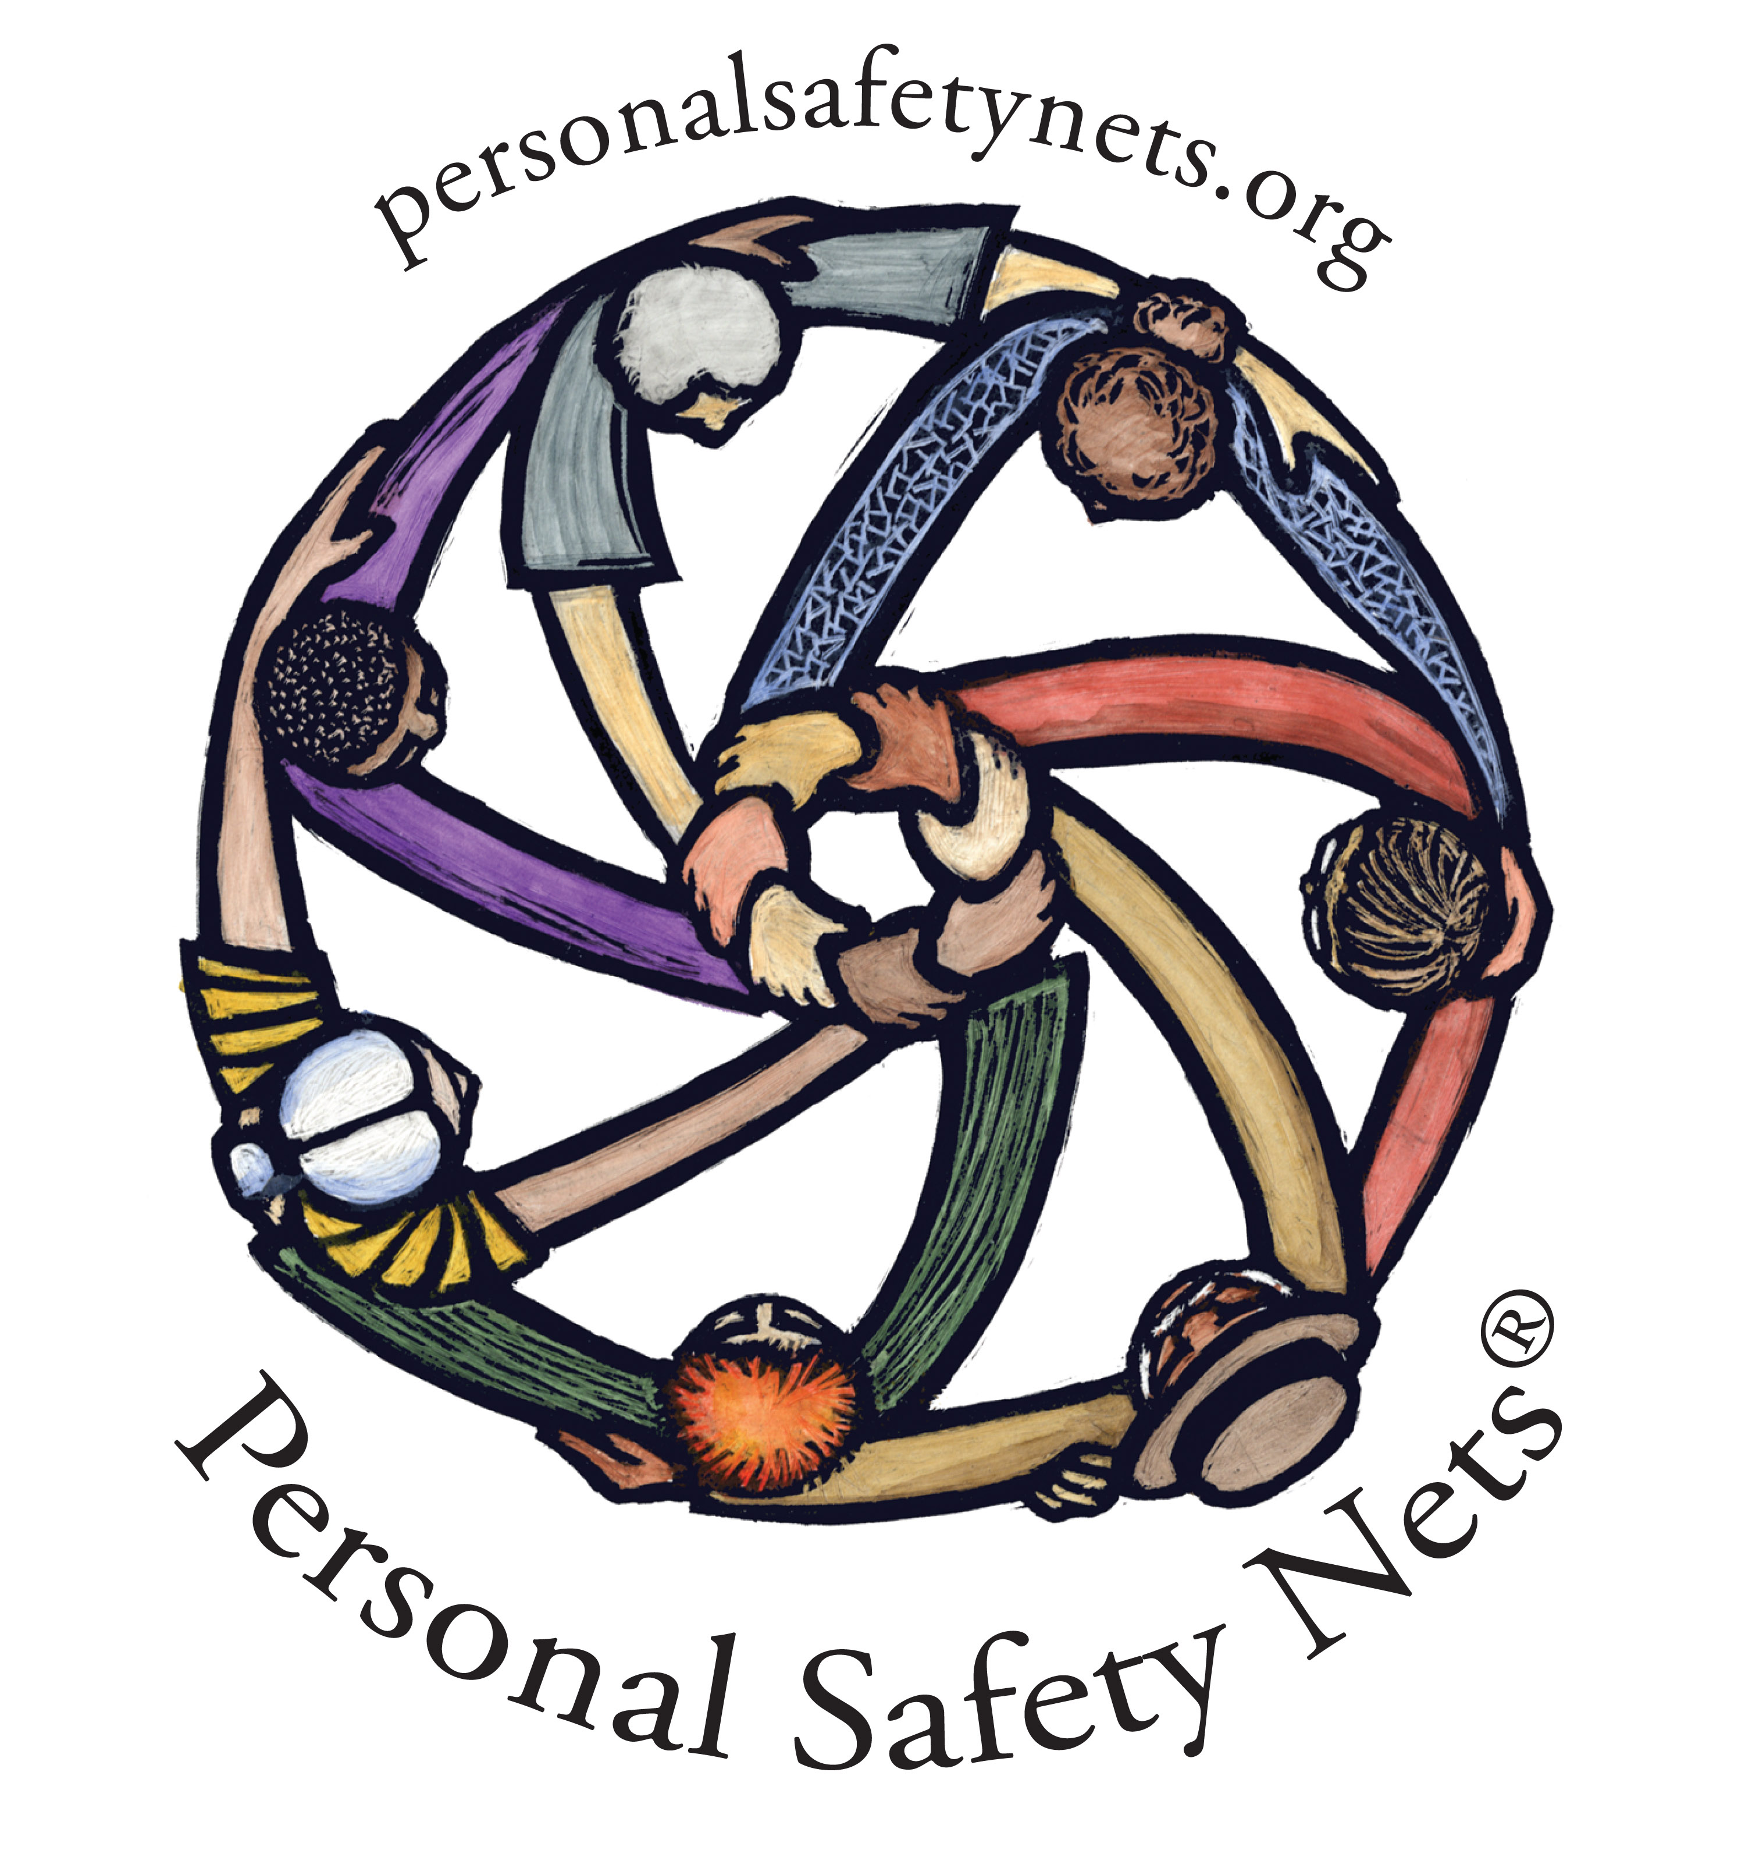
Personal Safety Nets Agenda Sample – 90 minutes
Understanding & Using Personal Safety Nets

Start with a short personal intro – your choice

- What is a personal safety net?
- A Personal Safety Nets provides a way of understanding a balance in your life that will make it possible for you to RESPOND, rather than to REACT to the predictably unpredictable changes or challenges that inevitably arise.

a. Philosophy behind a PSN:
- Replacing fear and isolation with security, connection and community.
- Knowing how you are interconnected helps you work with others - to help them connect!
- Change from “Sitting/Reacting” to “Acting/Responding/Planning” (and Avoiding Denial)

b. Make up of a PSN – The Definition: (handout: A PSN Diagram)
1) You, yourself: your capacities and qualities - for instance:
*courage, *tenacity, *organizational skills, *being a good listener,
* having the ability to engage others
2) Others: Family & Friends
3) Community: organizations, businesses, professionals
4) Plans

c. Exercise: Starting Your Own PSN (handout: Columns of a PSN)

** BETWEEN knowing what supports your PSN – having a team to help is an ASK!

2. (use: A Personal Survey) – Question #1-4: imbalance between most who want to help and the smaller number who are willing to ask for & receive help.

3. Things get in the WAY of reaching out / ASKING (handout: Things That Get in the Way) – Teacher can review the list, or if time allows, ask students about what specifically stops them from asking others.

Know it’s your right to ASK:
- YOU MATTER, and so does everyone else (We need to get others involved – which means asking for help.) We need to get others involved (they need us too)

- You matter to you, as leader in your own life, in others’ lives, in work, in community – You will need to get good at asking!

- We all have basic needs: 1) to be seen 2) to be heard 3) to matter to someone else

- So how do you go about ASKING EFFECTIVELY? (handout: Steps to Successful Asking)
- Try to be authentic!
- When you ASK
  - Set the stage with a SHORT picture of what’s going on
  - Give background – set the tone (include them in “your” team)
  - Include “the ask”

- Allow for “no” – Ask, don’t demand
  - Don’t take the particular answer personally – be grateful for AN answer
  - Think about 11 “other” reasons why you received a “no”
  - Think of a time when someone said “no” to a request…

- Accept what happens!

- When you are THE “asked”:
- Listen to the entire request
- Consider your response – if needed, can you think of alternatives & phrasing, ie.
    - You want to help and can’t/won’t (limits?)
    - You don’t want to help this person/ this time/ this request
    - You want to do your part.
    - Respond: Yes or NO –

- Both of you: Say thank you to each other (for a response, or for being asked)

  - Review (handout: Steps to Successful Asking)

- Using Your PSN to Organize & Create your first TEAM (a small safety net)
– “Wallet Cards” – hand out samples to all.
- Review (handouts: Using Your Wallet Card; What To Say To Others About Your Wallet Card)

5. All of PSN is based upon willingness to:
- Believe in abundance
- Value integrity and reputation
- See the power in choice
- Look at the stories we tell ourselves
- Recognize the importance of involving others in our lives

6. Evaluation & Q & A

